**Implementation Phase Report**

**Team ID: 4A17**

**Category: Application Development**

**Title: Appliance Store Management system**

**List of Team Members:**

|  |  |  |
| --- | --- | --- |
| **Roll number** | **USN** | **Name** |
| 43 | 01FE18BCS043 | Anusha Raikar |
| 44 | 01FE18BCS044 | Apoorva Jinde |
| 45 | 01FE18BCS045 | Archana Badagi |
| 54 | 01FE18BCS054 | Ashwini Banagar |

**Team Leader:** Apoorva Jinde

**Responsibilities:**

**Anusha Raikar:**

Collection of all data from the clients required for the project. Insertion of values GUI validations done.

**Apoorva Jinde:**

GUI implementation , Exceptions handling, plotting graphs.

**Archana Badagi:**

Interaction with the client. GUI frames,connections based on URL pathing

**Ashwini Banagar:**

GUI frames, connections and documentation done, final ppt prepared and designing of the web pages.

**Design updating:** [Describe the changes (if any) that need to be made to the Entity-Relationship Diagram you have given in Design Phase before it can be implemented as tables in SQL. If you identify any changes, redraw a new E/R diagram.]

DRAW YOUR NEW ENTITY RELATIONSHIP DIAGRAM HERE

**Implementation Phase Questions to be answered**

**Normalization:** [Any change in normal form as compared to design phase do include]

Data types have been changed for Employee ID,Customer Id ,AMC RecNo from CharField to Autofield.

And all the attributes having Integer field to Positive Integer Field

**-------------------------------------------------------------------------------------------------------------------**

**Question1:** Give the SQL statement(s) used to create the Oracle/MySQL database tables needed to implement the normalized relational schema.

**SQL COMMANDS**

CREATE TABLE amc (

RecNo varchar2(10) NOT NULL PRIMARY KEY,

MaintenanceYears int NOT NULL,

TotalServices int NOT NULL,

LastServiceDate date NOT NULL,

NoOfSrvcsDone int NOT NULL,

AMCQuantity int NOT NULL

);

CREATE TABLE customer (

C_Id varchar2(10) NOT NULL PRIMARY KEY,

C_Fname varchar2(20) NOT NULL,

C_Lname varchar2(20) NOT NULL,

PhoneNumber int NOT NULL,

CustAddress varchar2(50) NOT NULL

);

CREATE TABLE shop (

GSTNo varchar2(17) NOT NULL PRIMARY KEY,

S_Name varchar2(30) NOT NULL,

PhoneNint NOT NULL,

Location varchar2(100) NOT NULL

);

CREATE TABLE supplier_detail(

GSTSupplier varchar2(20) NOT NULL PRIMARY KEY,

S_Name varchar2(20) NOT NULL,

ContactNo int NOT NULL

);

CREATE TABLE supplier_transaction(

id int NOT NULL PRIMARY KEY AUTOINCREMENT,

DateOfSale date NOT NULL,

TotalAmt int NOT NULL,

Paid_Amt int NOT NULL,

GST_No_idvarchar2(20) NOT NULL

foreign key (GST_No_id) referencessupplier_detail(GSTSupplier)

);

CREATE TABLE product (

id int NOT NULL PRIMARY KEY AUTOINCREMENT,

ProductId varchar2(10) NOT NULL,

Brand varchar2(10) NOT NULL,

P_Name varchar2(50) NOT NULL,

Features varchar2(100) NOT NULL,

GSTAmt int NOT NULL,

TotalPriceint NOT NULL,

TotalQuantity int NOT NULL,

GSTnoShop_id varchar2(17) NOT NULL

foreign key (GSTnoShop_id) references Shop (GSTNo)

);

CREATE TABLE employee_details (

Empid varchar2(10) NOT NULL PRIMARY KEY,

E_FName varchar2(15) NOT NULL,

E_LName varchar2(15) NOT NULL,

AadharNo int NOT NULL,

JoinDate date NOT NULL,

Qualification varchar2(20) NOT NULL,

PhoneNo int NOT NULL,

Salary int NOT NULL,

Address varchar2(100) NOT NULL,

GSTnoShop_id varchar2(17) NOT NULL

foreign key (GSTnoShop_id) references Shop (GSTNo)

);

CREATE TABLE bill(

B_Id varchar2(15) NOT NULL PRIMARY KEY,

BDate date NOT NULL,

TotalAmt int NOT NULL,

PaidAmt int NOT NULL,

PaymentMode varchar2(10) NOT NULL,

Cust_Id_id varchar2(10) NOT NULL

foreign key (Cust_Id_id) references customer (C_Id)

);

CREATE TABLE supplies (

id int NOT NULL PRIMARY KEY AUTOINCREMENT,

Quantity int NOT NULL,

pro_info_id int NOT NULL

foreign key (pro_info_id) references product(id)

supp_info_id int NOT NULL

foreign key (supp_info_id)references supplier_transaction(id)

);

CREATE TABLE purchase(

id int NOT NULL PRIMARY KEY AUTOINCREMENT,

Quantity_purchase int NOT NULL,

Rec_no_id varchar2(10) NOT NULL

foreign key (Rec_no_id)references amc (RecNo)

bill_info_id varchar2(15) NOT NULL

foreign key (bill_info_id)references bill (B_Id)

prod_info_id int NOT NULL

foreign key (prod_info_id)references product(id)

);

--------------------------------------------------------------------------------------------------------------------------

**Question2:** Give the actual data stored in each table of the database. (real sample data)

WRITE THE ANSWER HERE

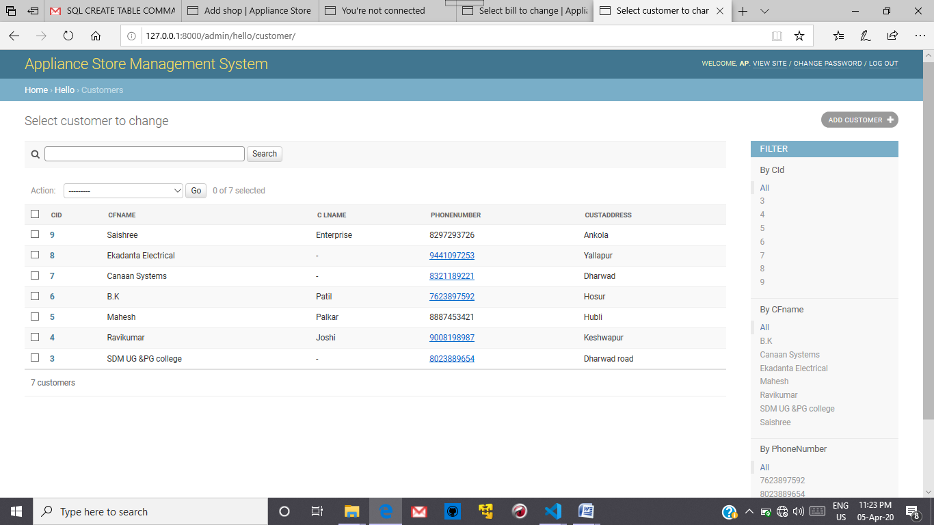

Figure .Customer Table

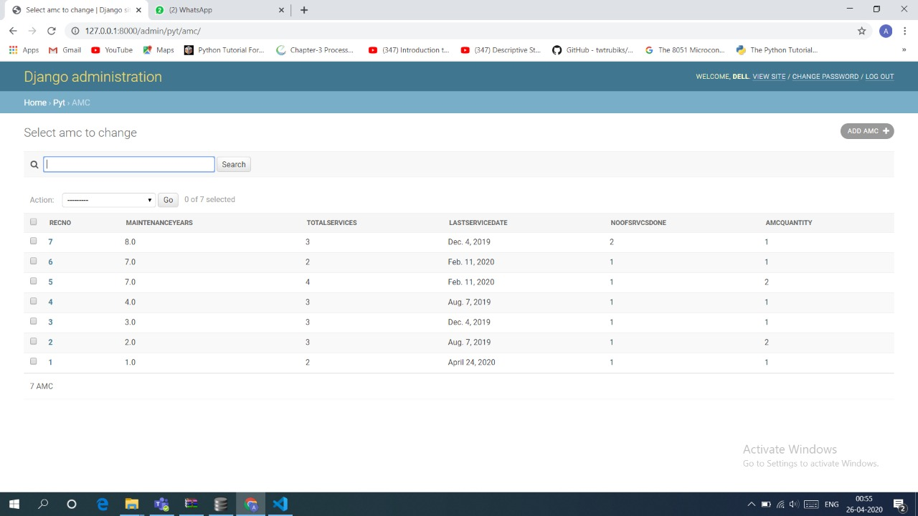

Figure AMC table

Figure 3 Bill Table

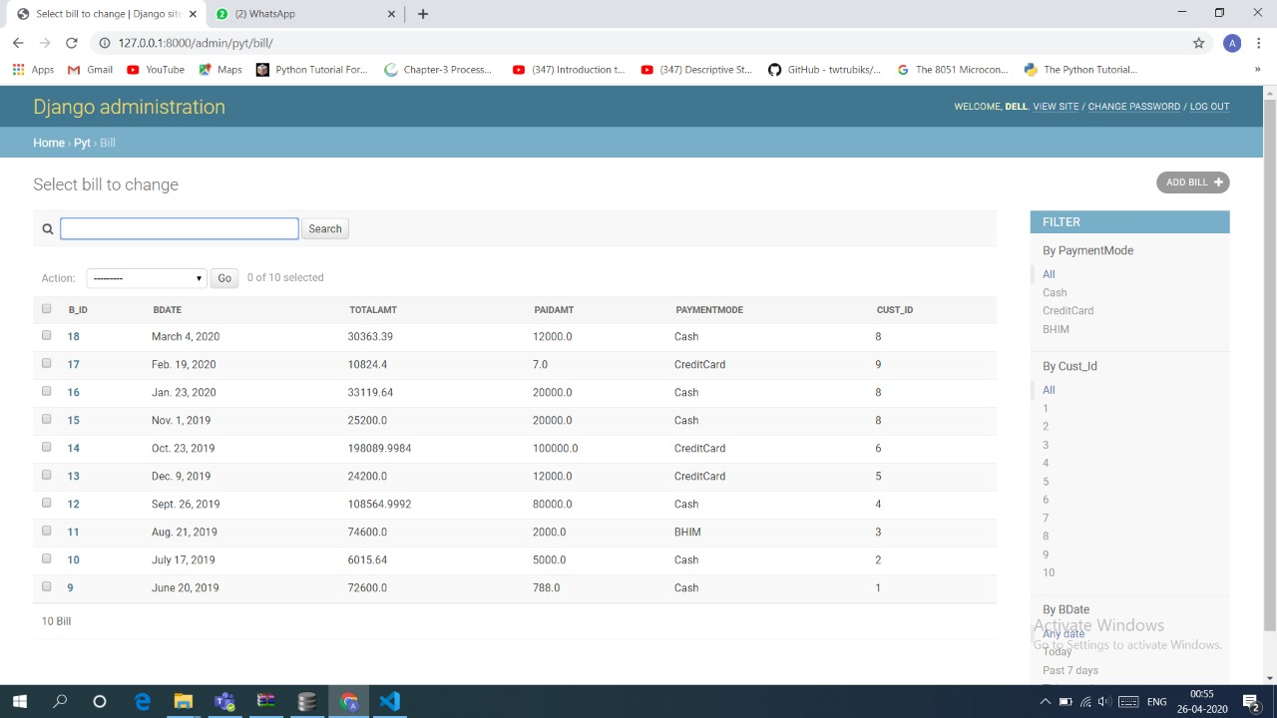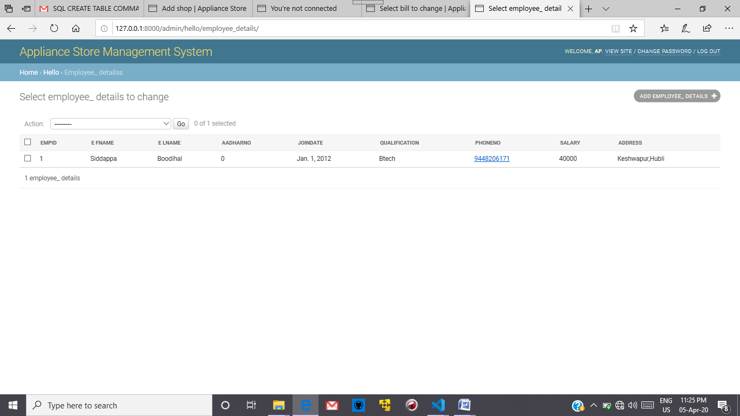

Figure Employee Table

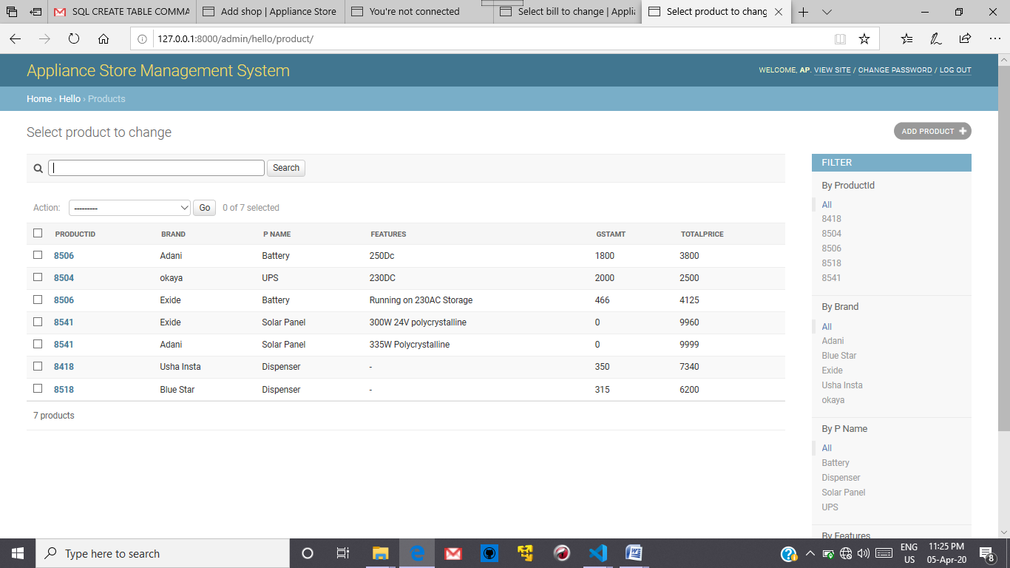

Figure Products Table

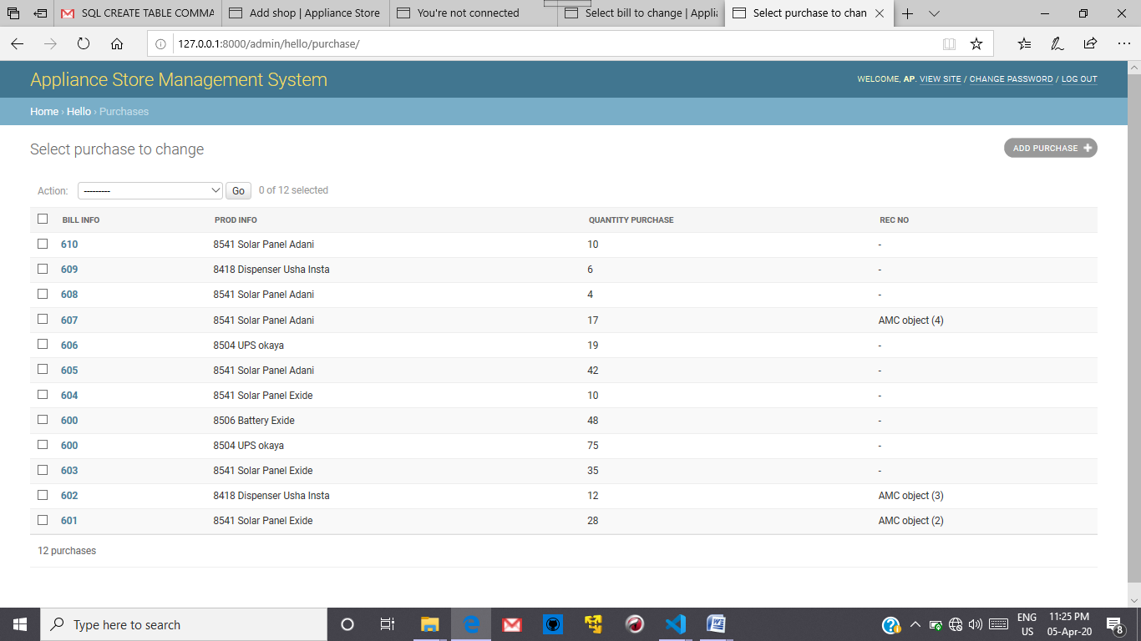

Figure Purchases Table

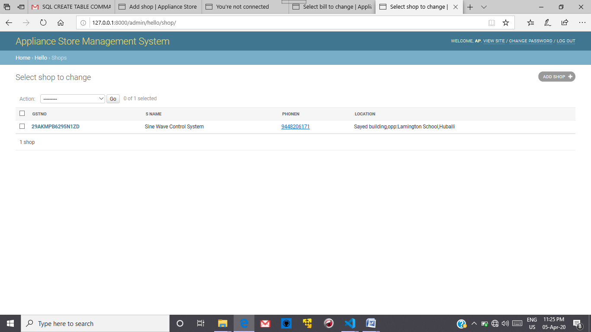

Figure Shop Details Table

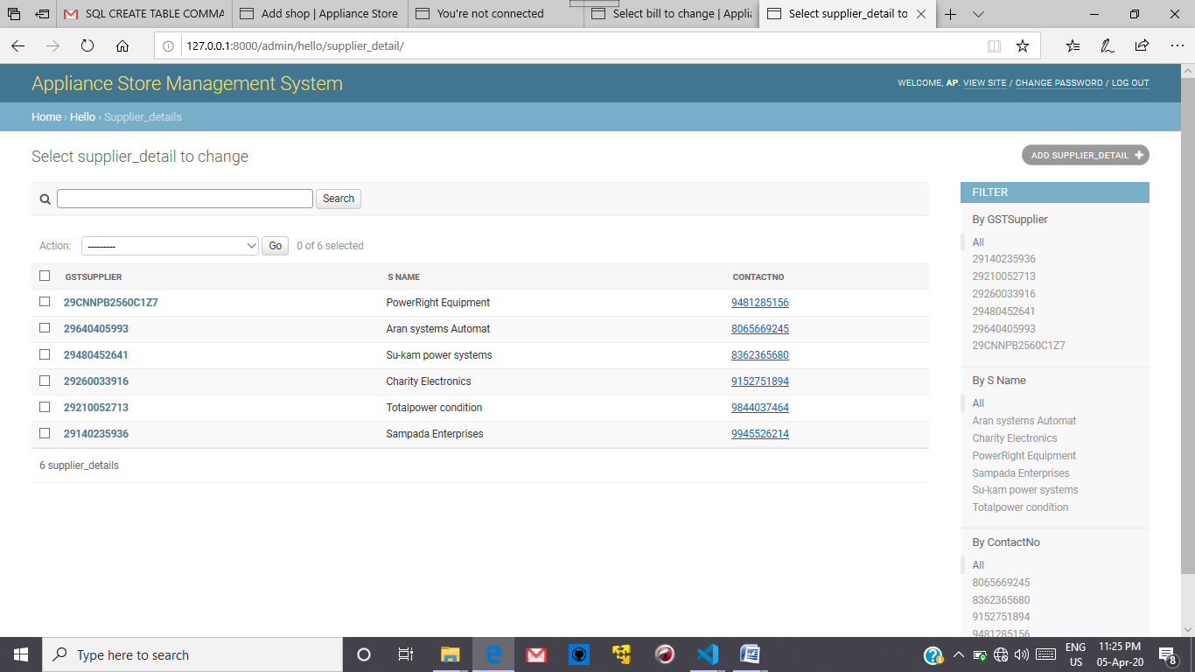

Figure Supplier_Details Table

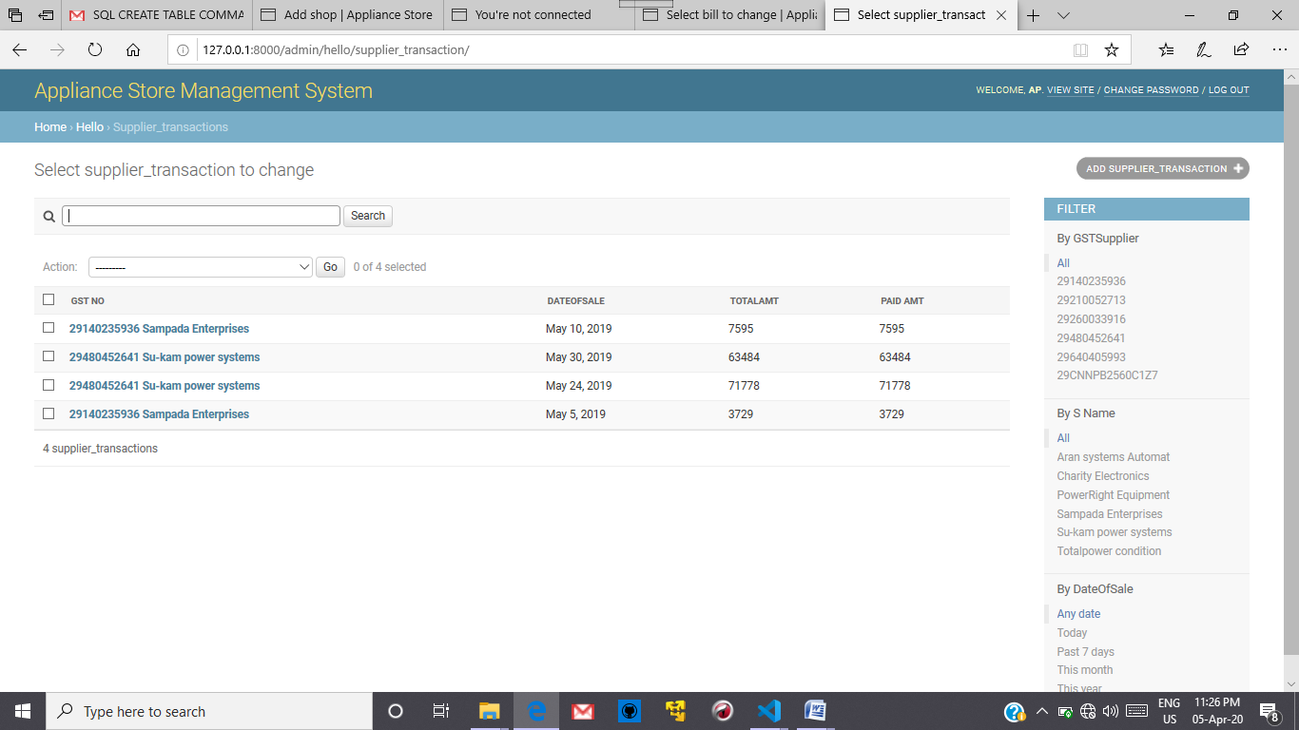

Figure Supplier_Transaction Table

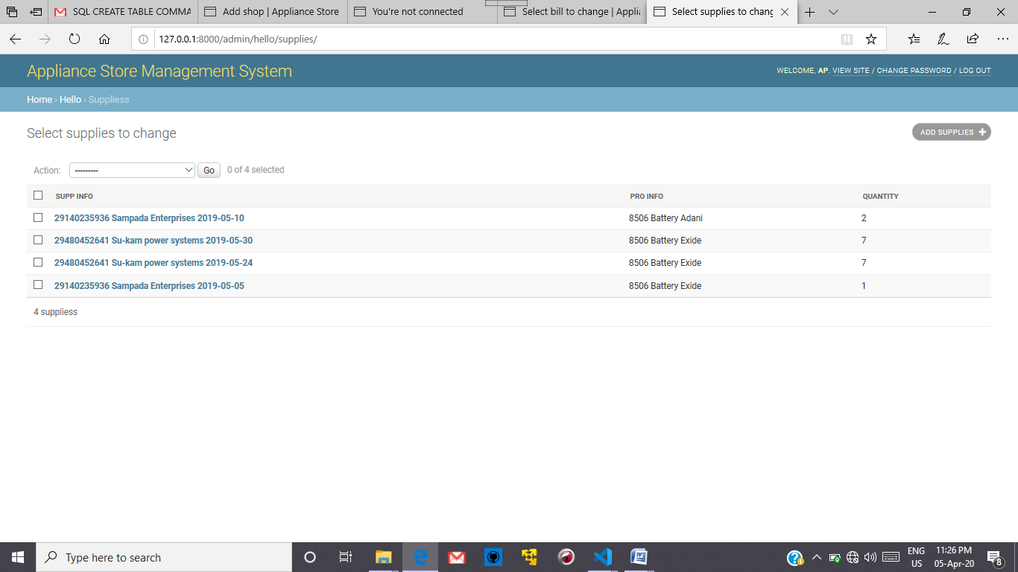

Figure Supplied Item Table

**Question3:** Give the snapshots, description and SQL queries for each of the user interface forms for your application. (Create the front end using Django and hook it up to the SQL.)

1) for details of customers in bill generated

q = Bill.objects.raw('SELECT * FROM Customer as C ,Bill as B WHERE C.C_Id=B.Cust_Id_id and B.B_Id=%s',[bill_no])

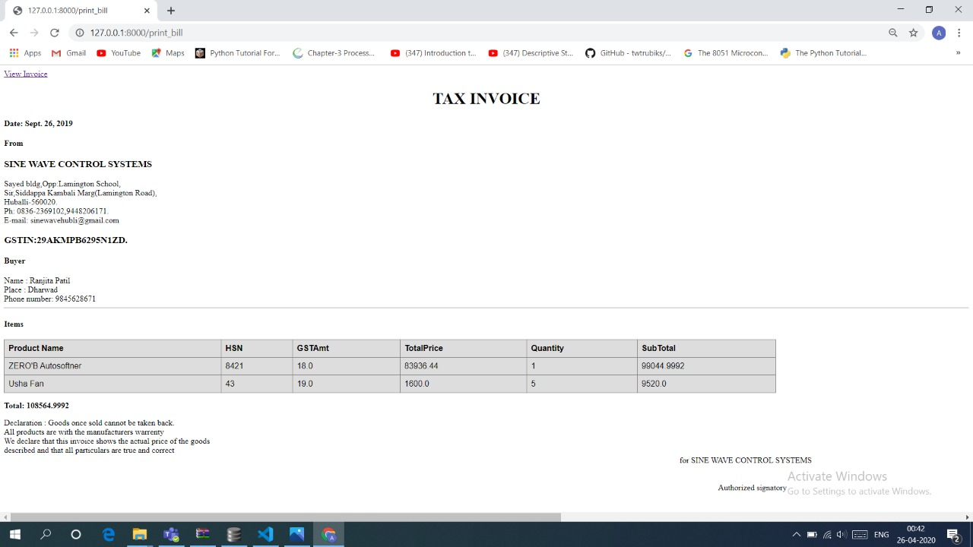

2)for details of product in bill generated

a = Product.objects.raw('SELECT * FROM Product as PR,Purchase as P WHERE PR.id=P.prod_info_id and P.bill_info_id=%s' ,[bill_no])



Both 1st and 2nd queries are included in a single view.

3)for details of due payments to suppliers

a=Supplier_transaction.objects.raw('SELECT * FROM Supplier_transaction WHERE Paid_Amt<TotalAmt')

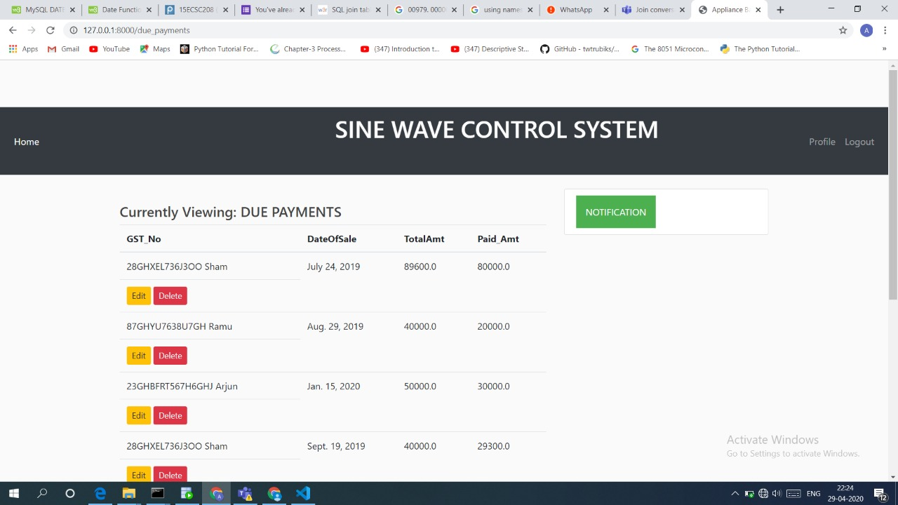

4)for details of due payments of customers

a=Bill.objects.raw('SELECT * FROM Bill WHERE PaidAmt<TotalAmt')

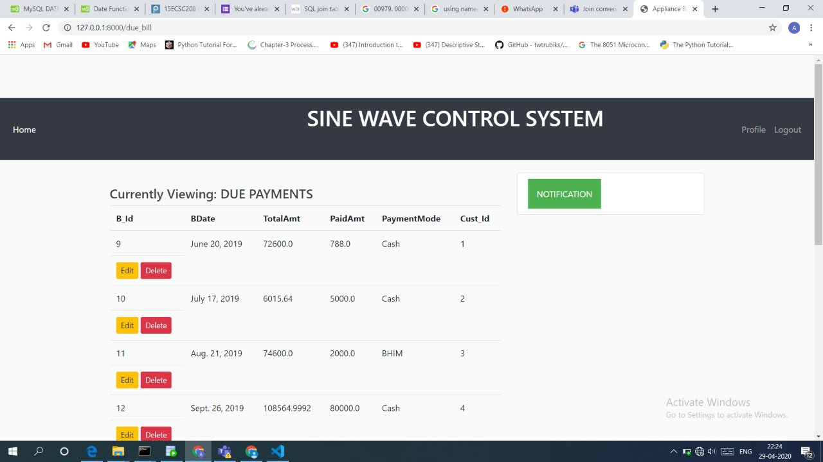

5)for due amc services

a=AMC.objects.raw('SELECT * FROM AMC WHERE NoOfSrvcsDone<TotalServices')

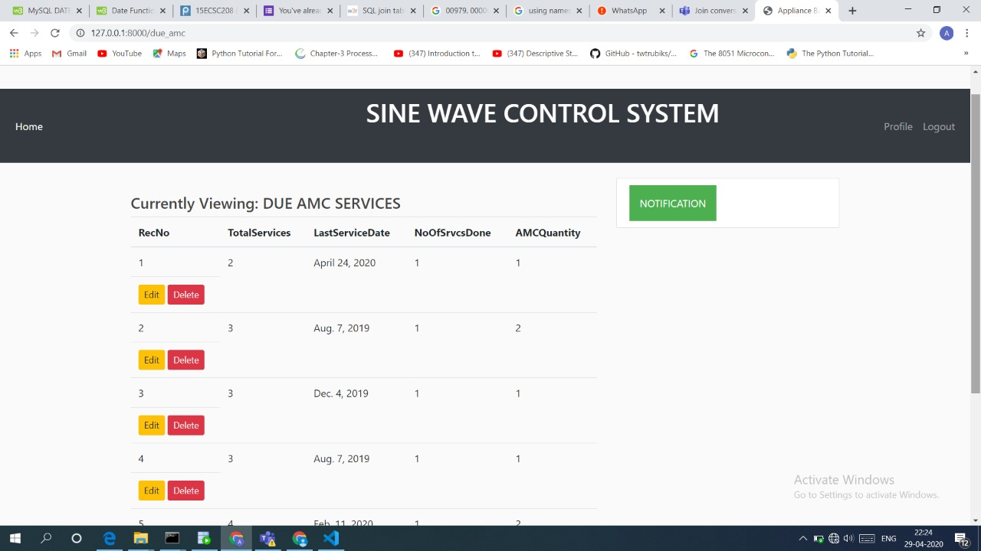

6)for sales graph

c.execute('SELECT substr(DateOfSale,1,7) as "Month", sum(TotalAmt) as Amount from Supplier_transaction group by substr(DateOfSale,1,7)')

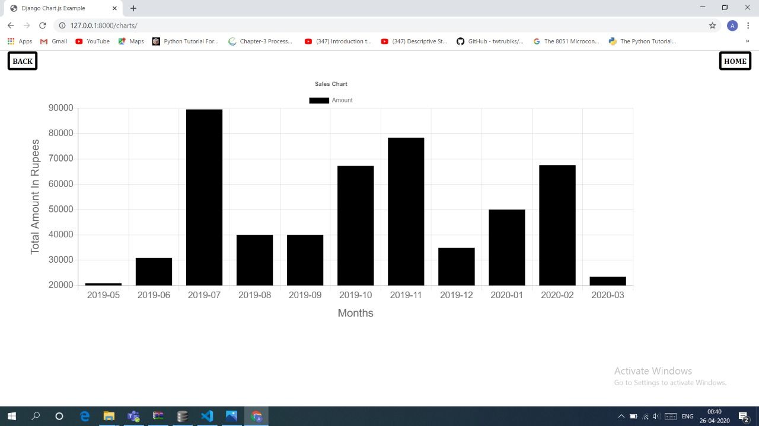

7)for purchase garph

c.execute('SELECT substr(BDate,1,7) as "Month", sum(TotalAmt) as Amount, B_Id from Bill group by substr(BDate,1,7)')

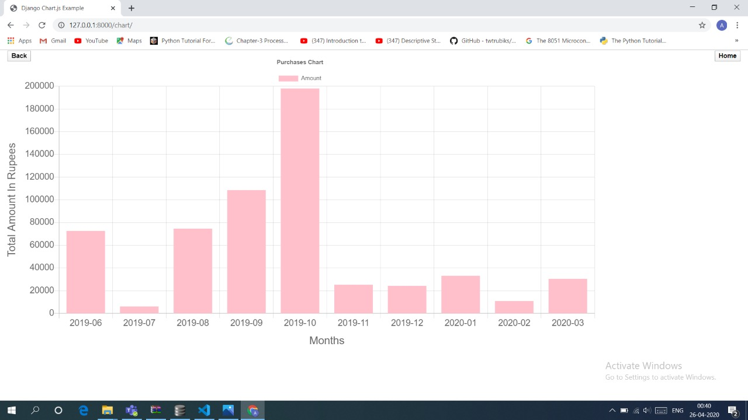

**Question4:** Give all possible final bill reports/other forms of ledger reports summarized etc and graphs obtained by your application.

This is the bill with automated calculation we get after entering the bill number

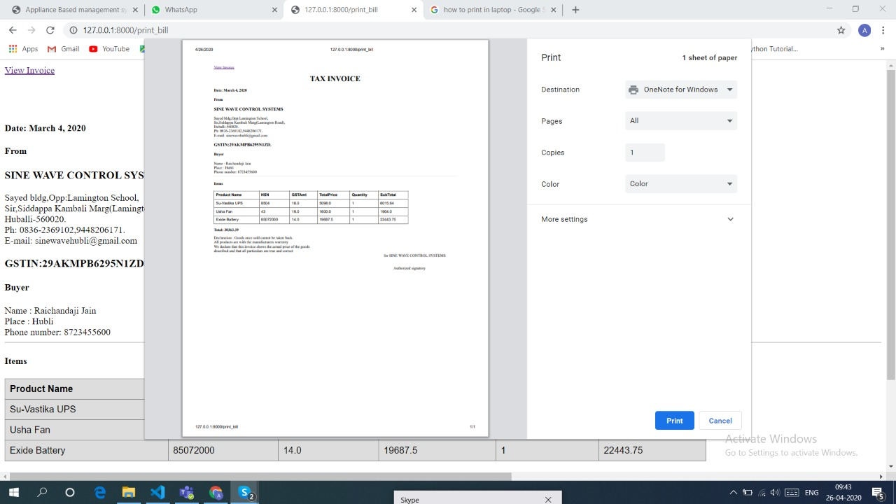

To convert to the pdf we need to click the button view invoice at the corner so that the pdf of the bill is generated



This is the annual Sales Report for the previous year



Purchase Analysis of the goods by the customers in the previous year

**Question5:** Any other matter you wish to add can do so (if necessary)

We have handled a few exception cases like phone number length validation, negative number validation.

Conditional validations like total amount cannot be less than paid amount , quantity purchased cannot be less than amc quantity are handled.

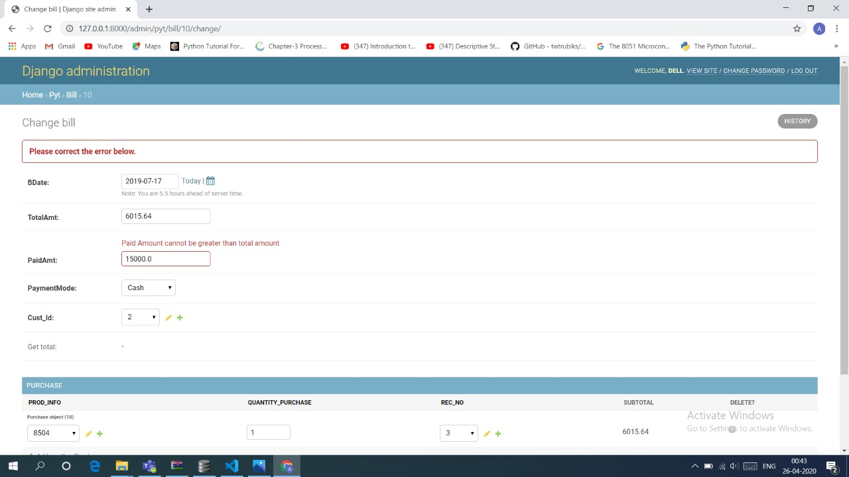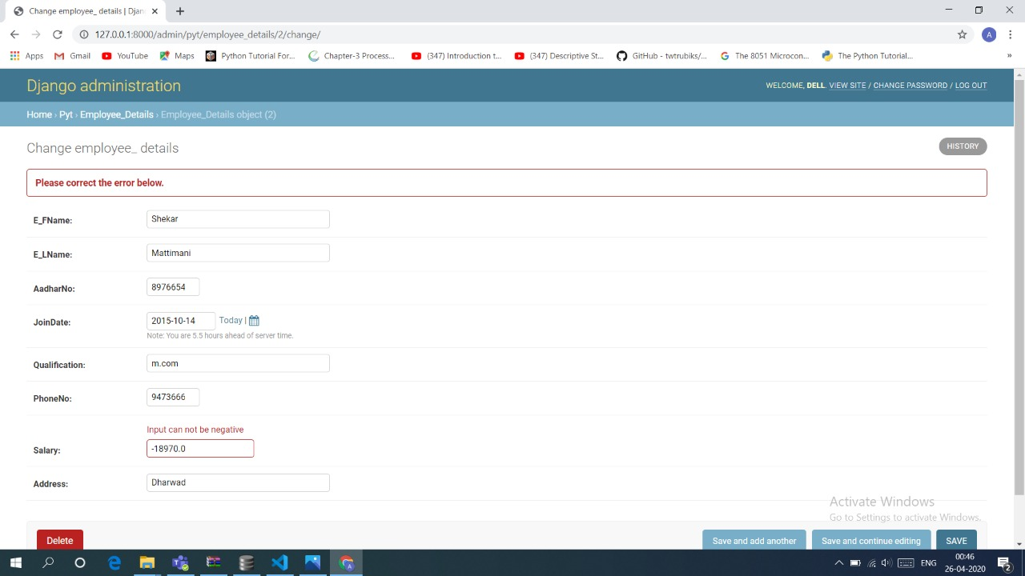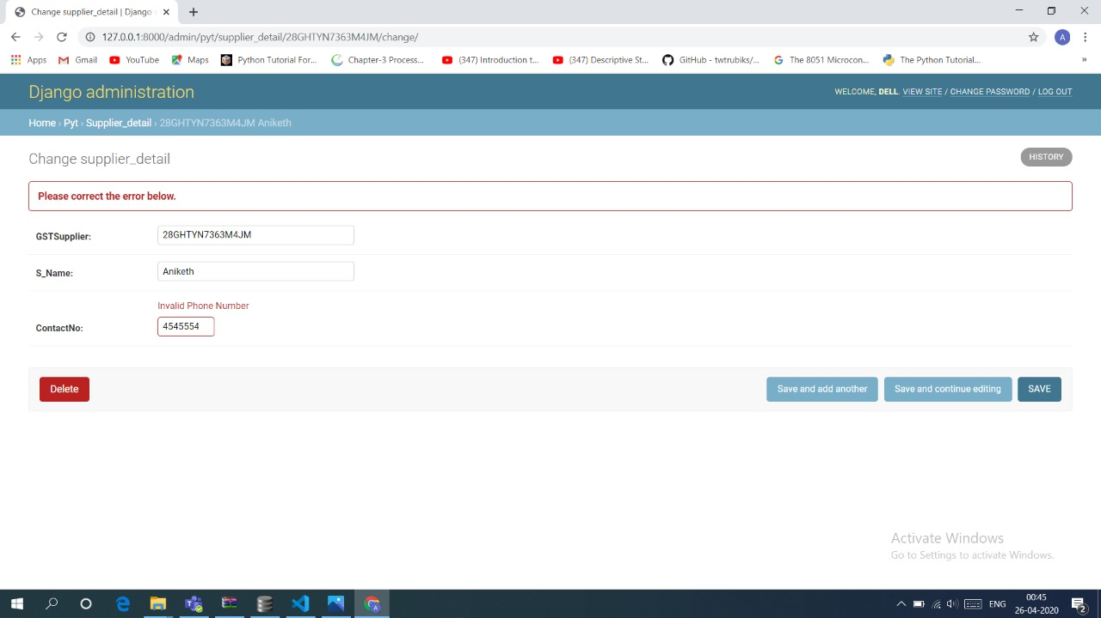

**Submission Date:05-04-2020**